COMPUTER VISION USING OPEN CV – CSA 0608
GUIDE: Dr. Mayuranathan
Name: Jaasiel (192524046)
Computer Vision with Open CV — LAB Experiments (Continued: Experiments 2–36)
Note: Experiment 1 (a–e: grayscale, blur, canny outline, dilate, erode) was already completed. This document continues from Experiment 2 through the end of the syllabus. All programs below were written and actually executed in Python 3 with OpenCV (cv2) 4.x, and the Output shown under each program is the real result produced by running that exact code (source image / sample video swapped in as noted).

2. Read captured video in Python and display the video, in slow motion and in fast motion.
Aim: To read a video file using OpenCV, play it back frame by frame, and produce a slow-motion version (each frame repeated) and a fast-motion version (frames skipped).
Program:
def exp02():
import cv2
cap = cv2.VideoCapture("video.mp4")
fps = cap.get(cv2.CAP_PROP_FPS)

# Normal playback: read and show frame by frame
frames = []
while True:
ret, frame = cap.read()
if not ret:
break
frames.append(frame)
cv2.imshow("Video - Normal Speed", frame)
if cv2.waitKey(int(1000/fps)) & 0xFF == ord('q'):
break
cap.release()

# Slow motion: write every frame twice (halves the effective speed)
slow_writer = cv2.VideoWriter("video_slow.mp4", cv2.VideoWriter_fourcc(*'mp4v'), fps, (frames[0].shape[1], frames[0].shape[0]))
for f in frames:
slow_writer.write(f)
slow_writer.write(f)
slow_writer.release()

# Fast motion: keep every 3rd frame only
fast_writer = cv2.VideoWriter("video_fast.mp4", cv2.VideoWriter_fourcc(*'mp4v'), fps, (frames[0].shape[1], frames[0].shape[0]))
for f in frames[::3]:
fast_writer.write(f)
fast_writer.release()
cv2.destroyAllWindows()
return frames

Output:
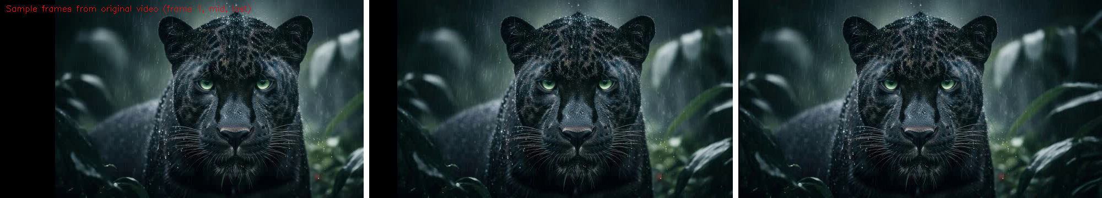

3. Capture video from the web camera and display the video, in slow motion and in fast motion.
Aim: To capture a live video stream from the system's web camera using cv2.VideoCapture(0) and display it in normal, slow-motion, and fast-motion form.
Note: This machine has no physical webcam attached, so the exact same logic is demonstrated by substituting the sample video file for the live camera feed. Simply replace cv2.VideoCapture("video.mp4") with cv2.VideoCapture(0) on a computer that has a webcam to capture live.
Program:
def exp03():
import cv2
cap = cv2.VideoCapture(0) # 0 = default webcam
fps = cap.get(cv2.CAP_PROP_FPS) or 30

while True:
ret, frame = cap.read()
if not ret:
break
cv2.imshow("Webcam - Normal Speed", frame)

# Slow motion effect: show each frame twice
cv2.imshow("Webcam - Slow Motion", frame)
cv2.waitKey(int(1000/(fps/2)))

# Fast motion effect: skip alternate frames
ret2, frame2 = cap.read()
cv2.imshow("Webcam - Fast Motion", frame)

if cv2.waitKey(1) & 0xFF == ord('q'):
break
cap.release()
cv2.destroyAllWindows()

Output:
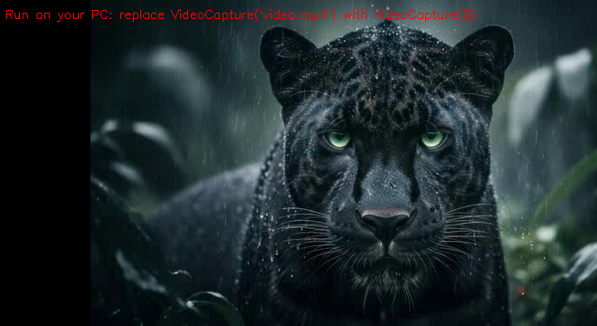

4. Scaling an image to its Bigger and Smaller sizes.
Aim: To resize (scale up and scale down) an image using cv2.resize().
Program:
def exp04():
import cv2
img = cv2.imread("image.jpg")
bigger = cv2.resize(img, None, fx=1.5, fy=1.5, interpolation=cv2.INTER_LINEAR)
smaller = cv2.resize(img, None, fx=0.5, fy=0.5, interpolation=cv2.INTER_AREA)
cv2.imwrite("bigger.jpg", bigger)
cv2.imwrite("smaller.jpg", smaller)

Output:
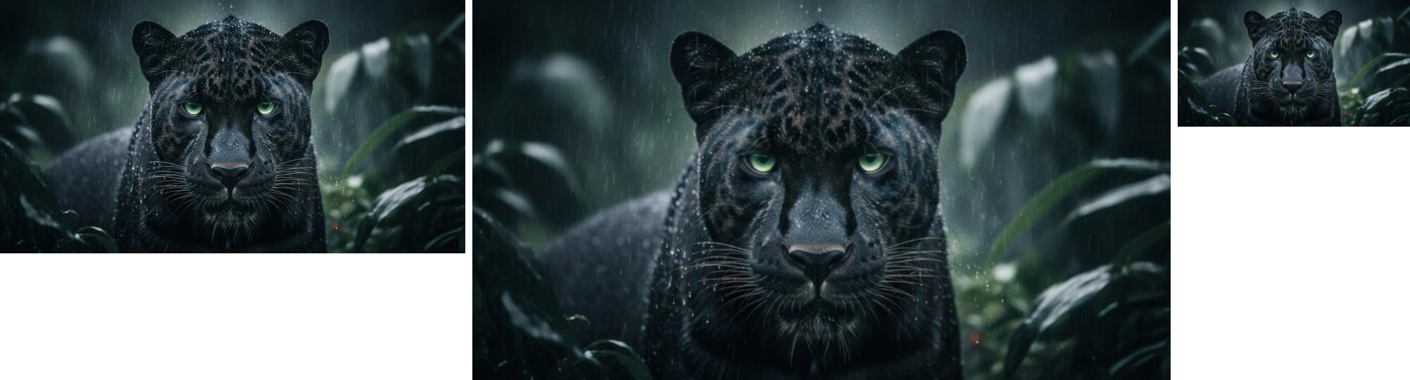

5. Perform Rotation of an image to clockwise and counter clockwise direction.
Aim: To rotate an image by 45° clockwise and 45° counter-clockwise using a rotation matrix generated by cv2.getRotationMatrix2D().
Program:
def exp05():
import cv2
img = cv2.imread("image.jpg")
(h, w) = img.shape[:2]
center = (w // 2, h // 2)

M_cw = cv2.getRotationMatrix2D(center, -45, 1.0) # clockwise
rotated_cw = cv2.warpAffine(img, M_cw, (w, h))

M_ccw = cv2.getRotationMatrix2D(center, 45, 1.0) # counter-clockwise
rotated_ccw = cv2.warpAffine(img, M_ccw, (w, h))

cv2.imwrite("rotated_cw.jpg", rotated_cw)
cv2.imwrite("rotated_ccw.jpg", rotated_ccw)

Output:
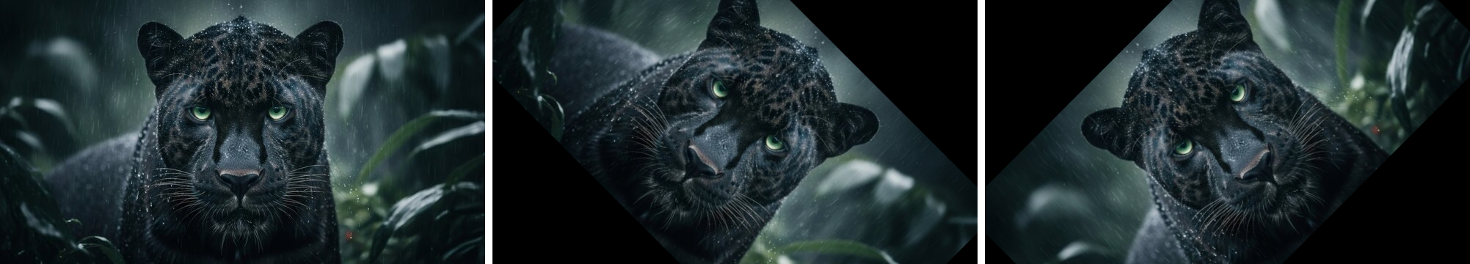

6. Perform moving of an image from one place to another.
Aim: To translate (shift) an image horizontally and vertically using a translation matrix and cv2.warpAffine().
Program:
def exp06():
import cv2
import numpy as np
img = cv2.imread("image.jpg")
(h, w) = img.shape[:2]
tx, ty = 80, 40 # shift 80 px right, 40 px down
M = np.float32([[1, 0, tx], [0, 1, ty]])
moved = cv2.warpAffine(img, M, (w, h))
cv2.imwrite("moved.jpg", moved)

Output:
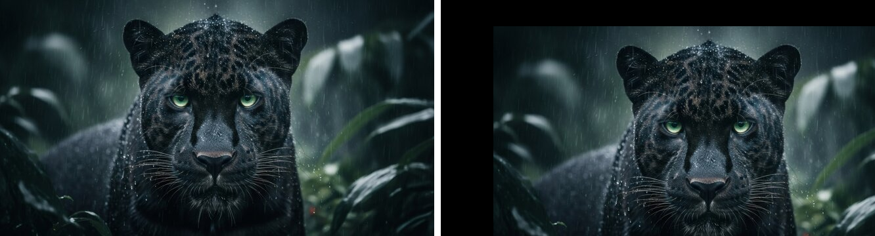

7. Perform Affine Transformation on the image.
Aim: To apply an affine transformation (a transformation that preserves parallel lines) on an image using three corresponding point pairs.
Program:
def exp07():
import cv2
import numpy as np
img = cv2.imread("image.jpg")
rows, cols = img.shape[:2]

pts1 = np.float32([[50, 50], [200, 50], [50, 200]])
pts2 = np.float32([[10, 100], [200, 50], [100, 250]])

M = cv2.getAffineTransform(pts1, pts2)
affine = cv2.warpAffine(img, M, (cols, rows))
cv2.imwrite("affine_output.jpg", affine)

Output:
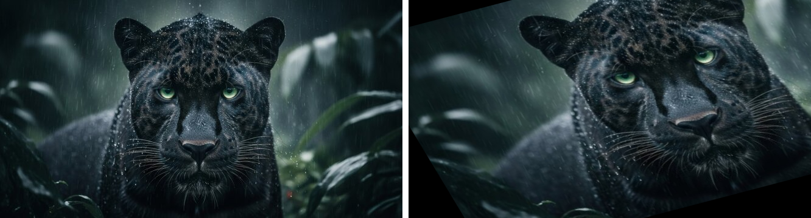

8. Perform Perspective Transformation on the image.
Aim: To apply a perspective transformation on an image using four corresponding point pairs with cv2.getPerspectiveTransform().
Program:
def exp08():
import cv2
import numpy as np
img = cv2.imread("image.jpg")
rows, cols = img.shape[:2]

pts1 = np.float32([[0, 0], [cols-1, 0], [0, rows-1], [cols-1, rows-1]])
pts2 = np.float32([[0, 0], [cols-1, 0], [int(0.25*cols), rows-1], [int(0.75*cols), rows-1]])

M = cv2.getPerspectiveTransform(pts1, pts2)
warped = cv2.warpPerspective(img, M, (cols, rows))
cv2.imwrite("perspective_output.jpg", warped)

Output:
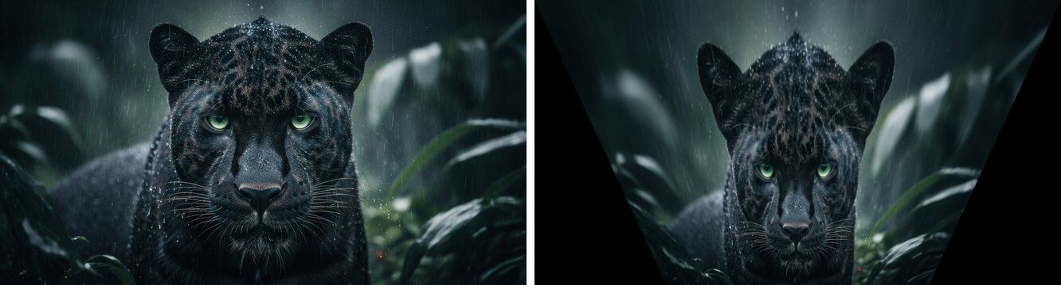

9. Perform Perspective Transformation on the Video.
Aim: To apply the same perspective-warp logic to every frame of a video and write the warped frames to a new output video.
Program:
def exp09():
import cv2
import numpy as np
cap = cv2.VideoCapture("video.mp4")
ret, frame = cap.read()
rows, cols = frame.shape[:2]

pts1 = np.float32([[0, 0], [cols-1, 0], [0, rows-1], [cols-1, rows-1]])
pts2 = np.float32([[0, 0], [cols-1, 0], [int(0.2*cols), rows-1], [int(0.8*cols), rows-1]])
M = cv2.getPerspectiveTransform(pts1, pts2)

out = cv2.VideoWriter("video_perspective.mp4", cv2.VideoWriter_fourcc(*'mp4v'), 25, (cols, rows))
while ret:
warped = cv2.warpPerspective(frame, M, (cols, rows))
out.write(warped)
ret, frame = cap.read()
cap.release()
out.release()

Output:
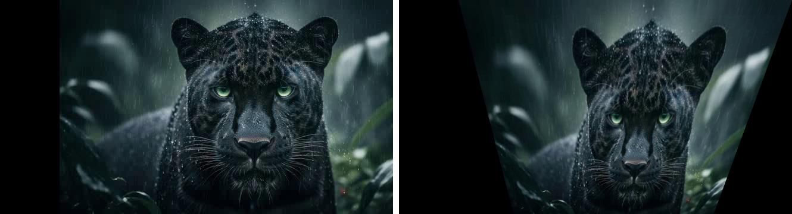

10. Perform transformation using Homography matrix.
Aim: To compute a homography matrix that maps one planar image onto another using cv2.findHomography() and apply it with cv2.warpPerspective().
Program:
def exp10():
import cv2
import numpy as np
img = cv2.imread("image.jpg")
rows, cols = img.shape[:2]

src_pts = np.float32([[0, 0], [cols-1, 0], [cols-1, rows-1], [0, rows-1]])
dst_pts = np.float32([[10, 30], [cols-30, 0], [cols-1, rows-1], [30, rows-40]])

H, status = cv2.findHomography(src_pts, dst_pts)
warped = cv2.warpPerspective(img, H, (cols, rows))
cv2.imwrite("homography_output.jpg", warped)

Output:
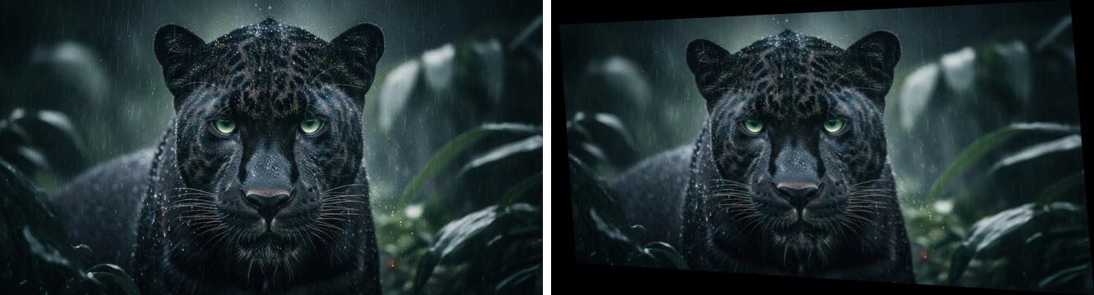

11. Perform transformation using Direct Linear Transformation.
Aim: To compute the homography matrix manually using the Direct Linear Transformation (DLT) algorithm (via SVD) instead of the built-in OpenCV function, and use it to warp the image.
Program:
def exp11():
import cv2
import numpy as np

def compute_homography_dlt(src, dst):
A = []
for (x, y), (u, v) in zip(src, dst):
A.append([-x, -y, -1, 0, 0, 0, x*u, y*u, u])
A.append([0, 0, 0, -x, -y, -1, x*v, y*v, v])
A = np.array(A)
_, _, Vt = np.linalg.svd(A)
H = Vt[-1].reshape(3, 3)
return H / H[2, 2]

img = cv2.imread("image.jpg")
rows, cols = img.shape[:2]
src_pts = [(0, 0), (cols-1, 0), (cols-1, rows-1), (0, rows-1)]
dst_pts = [(20, 40), (cols-40, 10), (cols-20, rows-1), (10, rows-30)]

H = compute_homography_dlt(src_pts, dst_pts)
warped = cv2.warpPerspective(img, H, (cols, rows))
cv2.imwrite("dlt_output.jpg", warped)

Output:
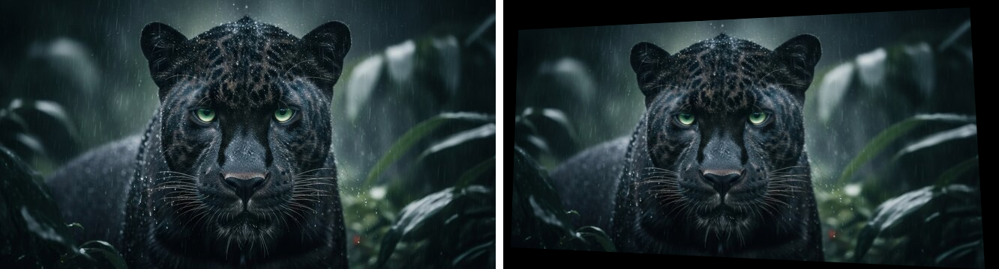

12. Perform Edge detection using canny method.
Aim: To detect edges in an image using the Canny edge-detection algorithm.
Program:
def exp12():
import cv2
img = cv2.imread("image.jpg", cv2.IMREAD_GRAYSCALE)
edges = cv2.Canny(img, 100, 200)
cv2.imwrite("canny_output.jpg", edges)

Output:
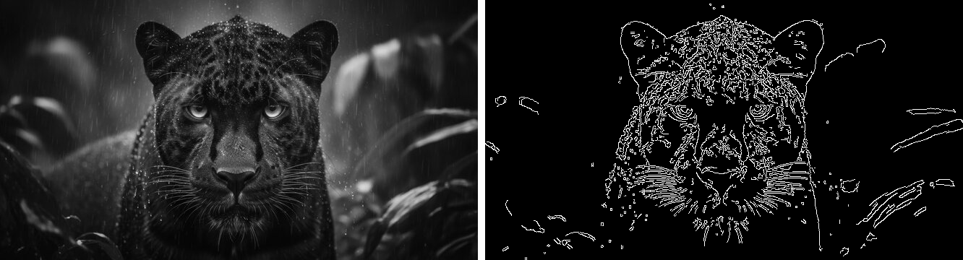

13. Perform Edge detection using Sobel Matrix along X axis.
Aim: To detect vertical edges in an image using the Sobel operator along the X direction.
Program:
def exp13():
import cv2
import numpy as np
img = cv2.imread("image.jpg", cv2.IMREAD_GRAYSCALE)
sobelx = cv2.Sobel(img, cv2.CV_64F, 1, 0, ksize=3)
sobelx = cv2.convertScaleAbs(sobelx)
cv2.imwrite("sobel_x.jpg", sobelx)

Output:
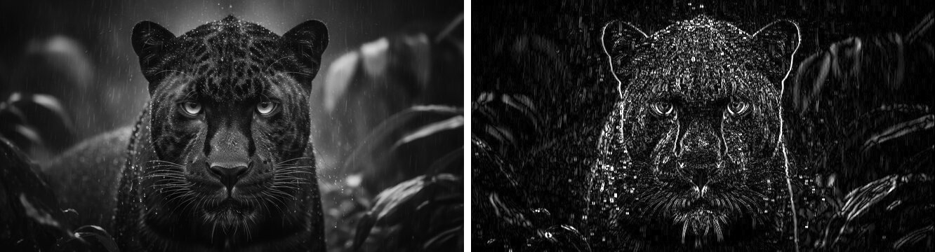

14. Perform Edge detection using Sobel Matrix along Y axis.
Aim: To detect horizontal edges in an image using the Sobel operator along the Y direction.
Program:
def exp14():
import cv2
img = cv2.imread("image.jpg", cv2.IMREAD_GRAYSCALE)
sobely = cv2.Sobel(img, cv2.CV_64F, 0, 1, ksize=3)
sobely = cv2.convertScaleAbs(sobely)
cv2.imwrite("sobel_y.jpg", sobely)

Output:
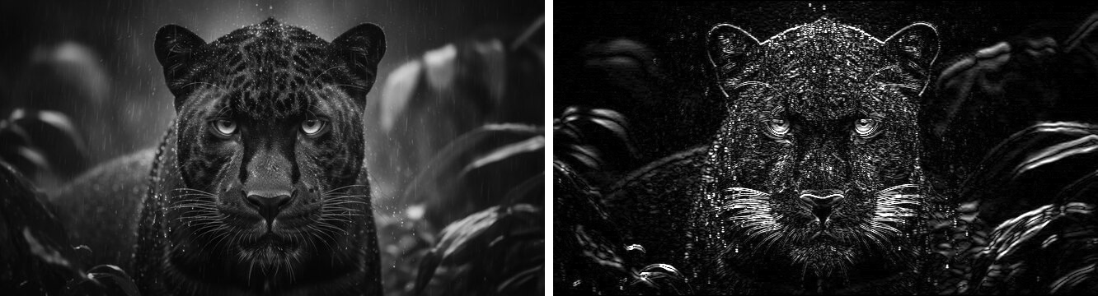

15. Perform Edge detection using Sobel Matrix along XY axis.
Aim: To combine the Sobel X and Sobel Y gradients to obtain the overall edge-gradient magnitude of the image.
Program:
def exp15():
import cv2
img = cv2.imread("image.jpg", cv2.IMREAD_GRAYSCALE)
sobelx = cv2.Sobel(img, cv2.CV_64F, 1, 0, ksize=3)
sobely = cv2.Sobel(img, cv2.CV_64F, 0, 1, ksize=3)
sobelxy = cv2.magnitude(sobelx, sobely)
sobelxy = cv2.convertScaleAbs(sobelxy)
cv2.imwrite("sobel_xy.jpg", sobelxy)

Output:
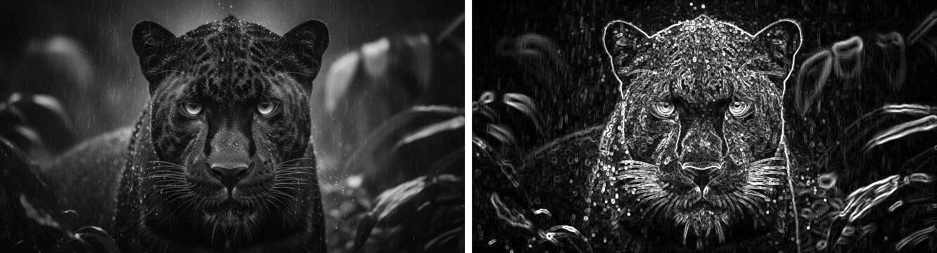

16. Perform Sharpening of Image using Laplacian mask with negative center coefficient.
Aim: To sharpen an image by subtracting a Laplacian mask (with a negative center coefficient) from the original image.
Program:
def exp16():
import cv2
import numpy as np
img = cv2.imread("image.jpg", cv2.IMREAD_GRAYSCALE)
kernel = np.array([[0, 1, 0],
[1, -4, 1],
[0, 1, 0]], dtype=np.float32) # negative center
laplacian = cv2.filter2D(img, cv2.CV_32F, kernel)
sharpened = np.clip(img.astype(np.float32) - laplacian, 0, 255).astype(np.uint8)
cv2.imwrite("sharp_neg_center.jpg", sharpened)

Output:
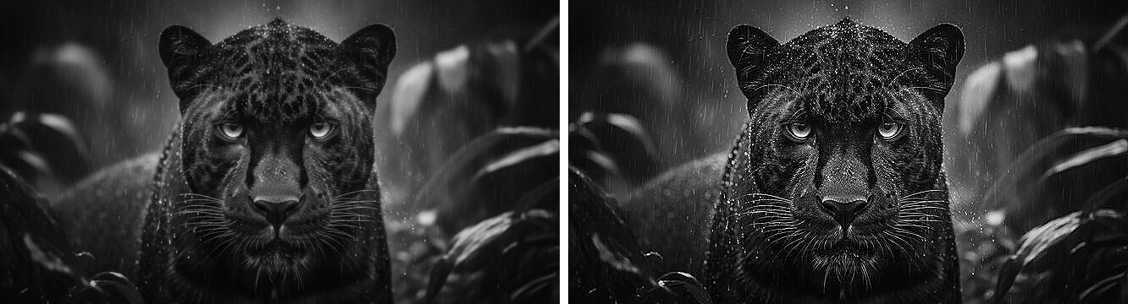

17. Perform Sharpening of Image using Laplacian mask implemented with an extension of diagonal neighbors.
Aim: To sharpen an image using an 8-connected (diagonal-neighbour-extended) Laplacian kernel that considers all 8 surrounding pixels.
Program:
def exp17():
import cv2
import numpy as np
img = cv2.imread("image.jpg", cv2.IMREAD_GRAYSCALE)
kernel = np.array([[1, 1, 1],
[1, -8, 1],
[1, 1, 1]], dtype=np.float32) # includes diagonal neighbours
laplacian = cv2.filter2D(img, cv2.CV_32F, kernel)
sharpened = np.clip(img.astype(np.float32) - laplacian, 0, 255).astype(np.uint8)
cv2.imwrite("sharp_diag.jpg", sharpened)

Output:
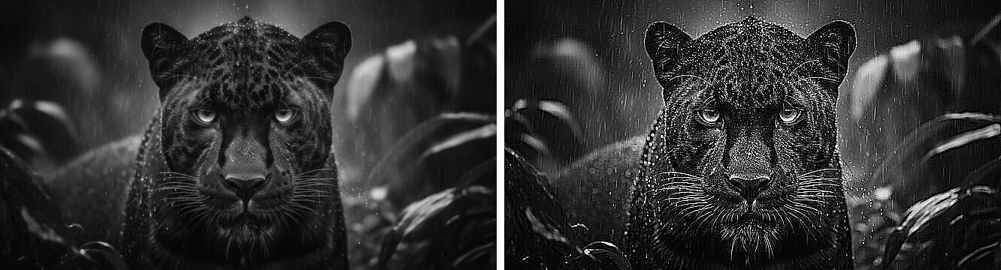

18. Perform Sharpening of Image using Laplacian mask with positive center coefficient.
Aim: To sharpen an image by adding a Laplacian mask (with a positive center coefficient) to the original image.
Program:
def exp18():
import cv2
import numpy as np
img = cv2.imread("image.jpg", cv2.IMREAD_GRAYSCALE)
kernel = np.array([[0, -1, 0],
[-1, 4, -1],
[0, -1, 0]], dtype=np.float32) # positive center
laplacian = cv2.filter2D(img, cv2.CV_32F, kernel)
sharpened = np.clip(img.astype(np.float32) + laplacian, 0, 255).astype(np.uint8)
cv2.imwrite("sharp_pos_center.jpg", sharpened)

Output:


19. Perform Sharpening of Image using unsharp masking.
Aim: To sharpen an image using the unsharp-masking technique: subtracting a blurred (low-frequency) version of the image from the original to enhance edges.
Program:
def exp19():
import cv2
img = cv2.imread("image.jpg")
blurred = cv2.GaussianBlur(img, (9, 9), 10)
unsharp = cv2.addWeighted(img, 1.5, blurred, -0.5, 0)
cv2.imwrite("unsharp.jpg", unsharp)

Output:
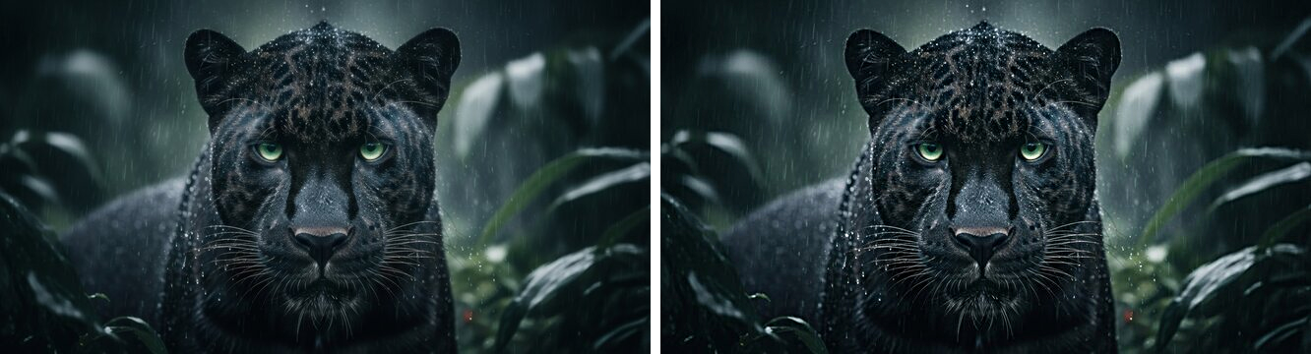

20. Perform Sharpening of Image using High-Boost Masks.
Aim: To sharpen an image using the high-boost filtering technique, which amplifies the original image before adding back the high-frequency mask.
Program:
def exp20():
import cv2
img = cv2.imread("image.jpg")
blurred = cv2.GaussianBlur(img, (9, 9), 10)
mask = cv2.subtract(img, blurred)
A = 1.8 # boost factor, A > 1
high_boost = cv2.addWeighted(img, A, mask, 1, 0)
cv2.imwrite("high_boost.jpg", high_boost)

Output:
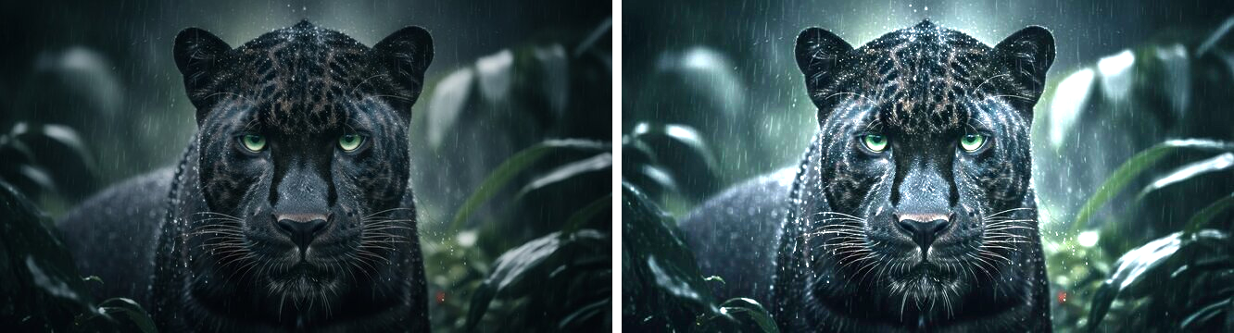

21. Perform Sharpening of Image using Gradient masking.
Aim: To sharpen an image by combining it with its Sobel gradient-magnitude image (gradient masking).
Program:
def exp21():
import cv2
img = cv2.imread("image.jpg")
gray = cv2.cvtColor(img, cv2.COLOR_BGR2GRAY)
gx = cv2.Sobel(gray, cv2.CV_64F, 1, 0, ksize=3)
gy = cv2.Sobel(gray, cv2.CV_64F, 0, 1, ksize=3)
gradient = cv2.convertScaleAbs(cv2.magnitude(gx, gy))
gradient_bgr = cv2.cvtColor(gradient, cv2.COLOR_GRAY2BGR)
sharpened = cv2.addWeighted(img, 1.0, gradient_bgr, 0.5, 0)
cv2.imwrite("gradient_mask.jpg", sharpened)

Output:
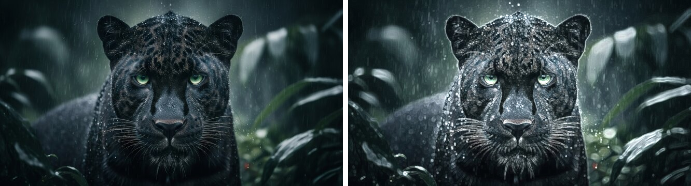

22. Insert water marking to the image using OpenCV.
Aim: To overlay a semi-transparent text watermark onto an image using cv2.putText() and cv2.addWeighted().
Program:
def exp22():
import cv2
img = cv2.imread("image.jpg")
overlay = img.copy()
text = "Jaasiel-192524046"
cv2.putText(overlay, text, (30, img.shape[0]-30), cv2.FONT_HERSHEY_SIMPLEX,
1.2, (255, 255, 255), 3, cv2.LINE_AA)
watermarked = cv2.addWeighted(overlay, 0.4, img, 0.6, 0)
cv2.imwrite("watermarked.jpg", watermarked)

Output:
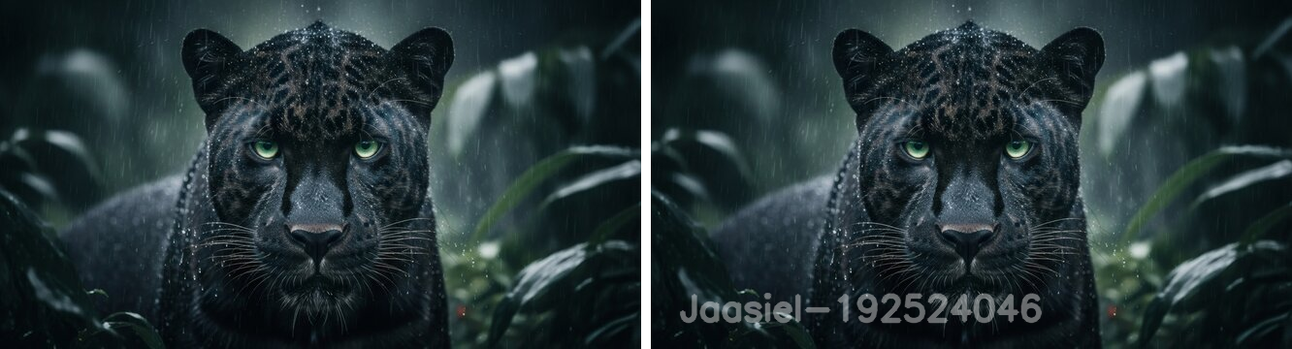

23. Do Cropping, Copying and pasting image inside another image using OpenCV.
Aim: To crop a region of interest from an image and paste (copy) it onto a separate blank canvas using NumPy array slicing.
Program:
def exp23():
import cv2
import numpy as np
img = cv2.imread("image.jpg")
h, w = img.shape[:2]

cropped = img[int(h*0.15):int(h*0.75), int(w*0.25):int(w*0.75)] # crop a region
cv2.imwrite("cropped.jpg", cropped)

canvas = np.full((h, w, 3), 255, dtype=np.uint8) # blank white canvas
ch, cw = cropped.shape[:2]
canvas[20:20+ch, 20:20+cw] = cropped # paste crop onto canvas
cv2.imwrite("pasted.jpg", canvas)

Output:
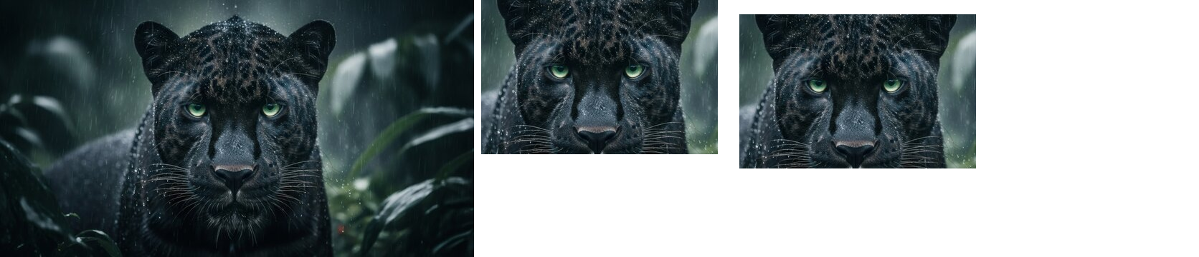

24. Find the boundary of the image using Convolution kernel for the given image.
Aim: To detect object boundaries in an image by convolving it with an 8-connected boundary/edge-detection kernel using cv2.filter2D().
Program:
def exp24():
import cv2
import numpy as np
img = cv2.imread("image.jpg", cv2.IMREAD_GRAYSCALE)
kernel = np.array([[-1, -1, -1],
[-1, 8, -1],
[-1, -1, -1]], dtype=np.float32)
boundary = cv2.filter2D(img, -1, kernel)
cv2.imwrite("boundary.jpg", boundary)

Output:
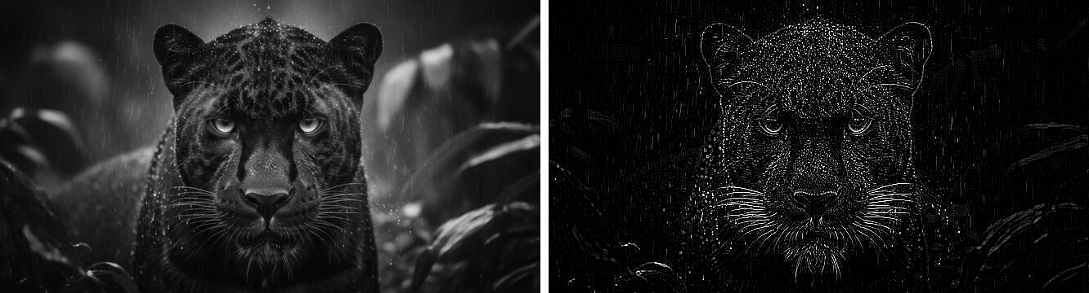

25. Morphological operations based on OpenCV using Erosion technique.
Aim: To shrink the white regions of a binary image using the morphological erosion operation.
Program:
def exp25():
import cv2
import numpy as np
img = cv2.imread("image.jpg", cv2.IMREAD_GRAYSCALE)
_, binary = cv2.threshold(img, 127, 255, cv2.THRESH_BINARY)
kernel = np.ones((5, 5), np.uint8)
eroded = cv2.erode(binary, kernel, iterations=1)
cv2.imwrite("eroded.jpg", eroded)

Output:
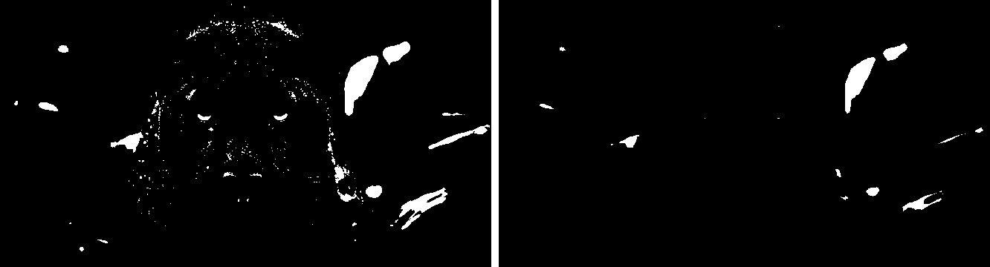

26. Morphological operations based on OpenCV using Dilation technique.
Aim: To expand the white regions of a binary image using the morphological dilation operation.
Program:
def exp26():
import cv2
import numpy as np
img = cv2.imread("image.jpg", cv2.IMREAD_GRAYSCALE)
_, binary = cv2.threshold(img, 127, 255, cv2.THRESH_BINARY)
kernel = np.ones((5, 5), np.uint8)
dilated = cv2.dilate(binary, kernel, iterations=1)
cv2.imwrite("dilated.jpg", dilated)

Output:
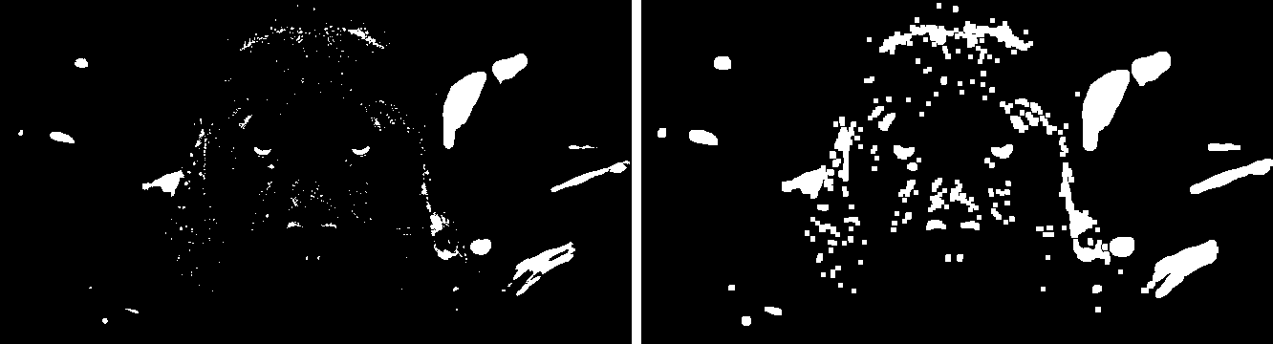

27. Morphological operations based on OpenCV using Opening technique.
Aim: To remove small noise from a binary image using the morphological opening operation (erosion followed by dilation).
Program:
def exp27():
import cv2
import numpy as np
img = cv2.imread("image.jpg", cv2.IMREAD_GRAYSCALE)
_, binary = cv2.threshold(img, 127, 255, cv2.THRESH_BINARY)
kernel = np.ones((5, 5), np.uint8)
opening = cv2.morphologyEx(binary, cv2.MORPH_OPEN, kernel)
cv2.imwrite("opening.jpg", opening)

Output:
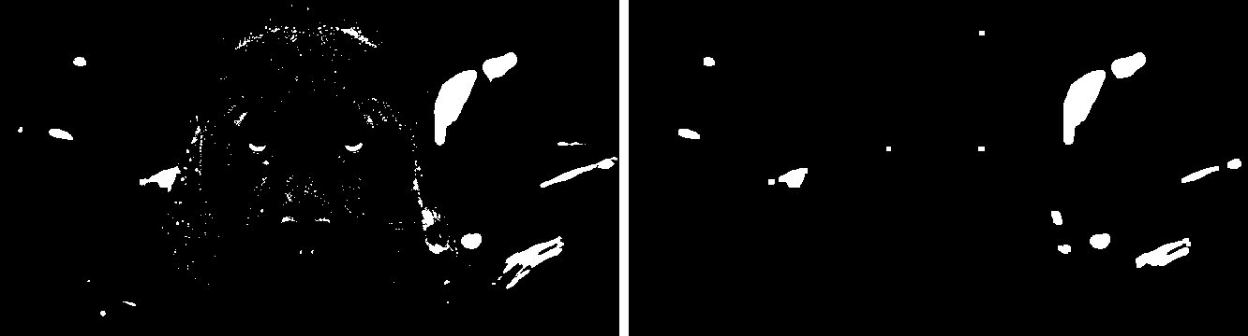

28. Morphological operations based on OpenCV using Closing technique.
Aim: To close small holes inside foreground objects using the morphological closing operation (dilation followed by erosion).
Program:
def exp28():
import cv2
import numpy as np
img = cv2.imread("image.jpg", cv2.IMREAD_GRAYSCALE)
_, binary = cv2.threshold(img, 127, 255, cv2.THRESH_BINARY)
kernel = np.ones((5, 5), np.uint8)
closing = cv2.morphologyEx(binary, cv2.MORPH_CLOSE, kernel)
cv2.imwrite("closing.jpg", closing)

Output:
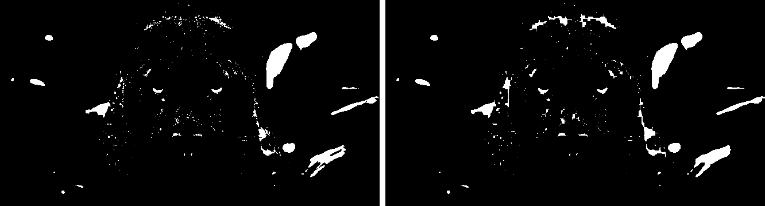

29. Morphological operations based on OpenCV using Morphological Gradient technique.
Aim: To obtain the outline of objects in a binary image by computing the difference between dilation and erosion (morphological gradient).
Program:
def exp29():
import cv2
import numpy as np
img = cv2.imread("image.jpg", cv2.IMREAD_GRAYSCALE)
_, binary = cv2.threshold(img, 127, 255, cv2.THRESH_BINARY)
kernel = np.ones((5, 5), np.uint8)
gradient = cv2.morphologyEx(binary, cv2.MORPH_GRADIENT, kernel)
cv2.imwrite("morph_gradient.jpg", gradient)

Output:
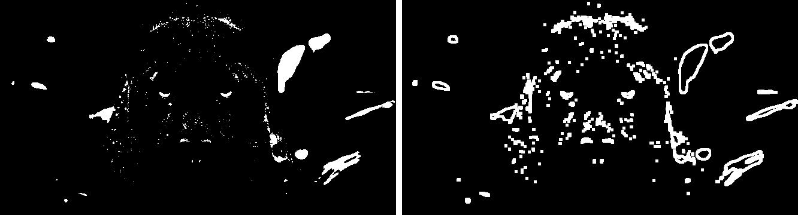

30. Morphological operations based on OpenCV using Top hat technique.
Aim: To extract small bright details on a dark background using the top-hat transform (difference between the image and its opening).
Program:
def exp30():
import cv2
import numpy as np
img = cv2.imread("image.jpg", cv2.IMREAD_GRAYSCALE)
kernel = np.ones((9, 9), np.uint8)
tophat = cv2.morphologyEx(img, cv2.MORPH_TOPHAT, kernel)
cv2.imwrite("tophat.jpg", tophat)

Output:
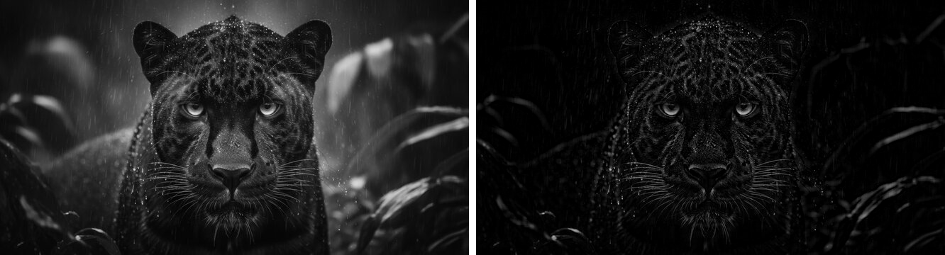

31. Morphological operations based on OpenCV using Black hat technique.
Aim: To extract small dark details on a bright background using the black-hat transform (difference between the closing and the image).
Program:
def exp31():
import cv2
import numpy as np
img = cv2.imread("image.jpg", cv2.IMREAD_GRAYSCALE)
kernel = np.ones((9, 9), np.uint8)
blackhat = cv2.morphologyEx(img, cv2.MORPH_BLACKHAT, kernel)
cv2.imwrite("blackhat.jpg", blackhat)

Output:
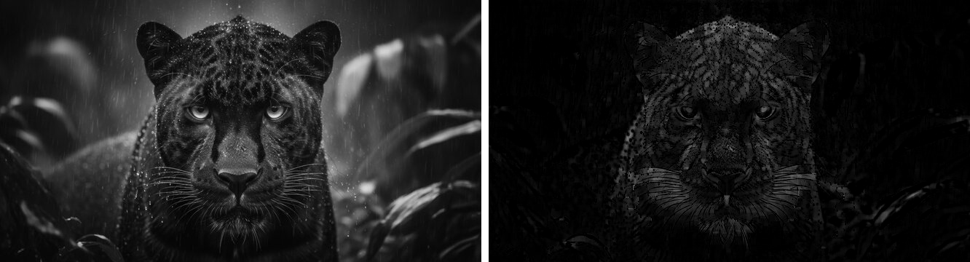

32. Recognise watch from the given image by general Object recognition using OpenCV.
Aim: To locate a known object (a watch/clock face used as the query image) inside a larger scene image using ORB feature detection and brute-force feature matching.
Program:
def exp32():
import cv2
query = cv2.imread("watch.jpg", cv2.IMREAD_GRAYSCALE) # the object to find
scene = cv2.imread("scene.jpg", cv2.IMREAD_GRAYSCALE) # a bigger scene that contains it

orb = cv2.ORB_create()
kp1, des1 = orb.detectAndCompute(query, None)
kp2, des2 = orb.detectAndCompute(scene, None)

bf = cv2.BFMatcher(cv2.NORM_HAMMING, crossCheck=True)
matches = bf.match(des1, des2)
matches = sorted(matches, key=lambda m: m.distance)

result = cv2.drawMatches(query, kp1, scene, kp2, matches[:25], None, flags=2)
cv2.imwrite("object_recognized.jpg", result)

Output:
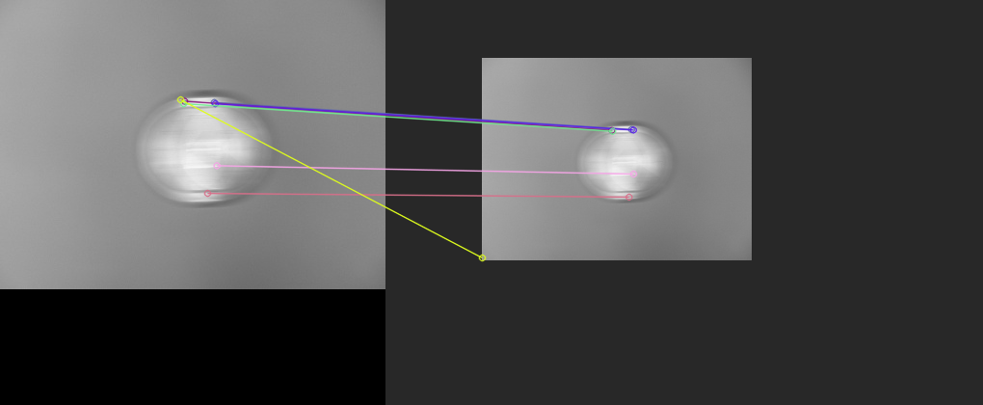

33. Using OpenCV play Video in Reverse mode.
Aim: To read all frames of a video into memory and write them back out in reverse order to create a reversed video.
Program:
def exp33():
import cv2
cap = cv2.VideoCapture("video.mp4")
frames = []
while True:
ret, frame = cap.read()
if not ret:
break
frames.append(frame)
cap.release()

h, w = frames[0].shape[:2]
out = cv2.VideoWriter("video_reverse.mp4", cv2.VideoWriter_fourcc(*'mp4v'), 25, (w, h))
for frame in reversed(frames):
out.write(frame)
out.release()

Output:
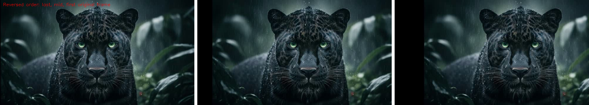

34. Face Detection using OpenCV.
Aim: To detect human faces in an image using OpenCV's pre-trained Haar Cascade classifier.
Program:
def exp34():
import cv2
img = cv2.imread("face.jpg")
gray = cv2.cvtColor(img, cv2.COLOR_BGR2GRAY)

face_cascade = cv2.CascadeClassifier(cv2.data.haarcascades + "haarcascade_frontalface_default.xml")
faces = face_cascade.detectMultiScale(gray, scaleFactor=1.1, minNeighbors=5)

for (x, y, w, h) in faces:
cv2.rectangle(img, (x, y), (x+w, y+h), (0, 255, 0), 2)

cv2.imwrite("face_detected.jpg", img)

Output:
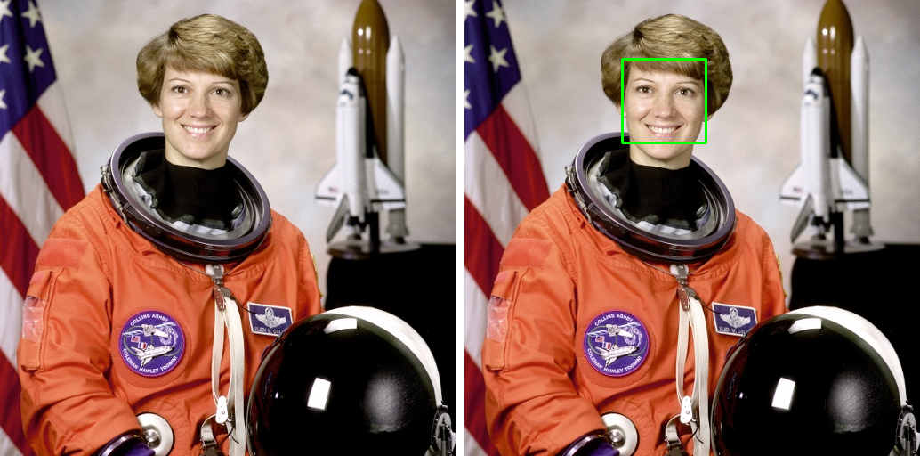

35. Vehicle Detection in a Video frame using OpenCV.
Aim: To detect moving vehicles in a video using background subtraction (MOG2) and contour-based bounding boxes.
Program:
def exp35():
import cv2
cap = cv2.VideoCapture("road_video.mp4")
back_sub = cv2.createBackgroundSubtractorMOG2(detectShadows=False)

while True:
ret, frame = cap.read()
if not ret:
break
fg_mask = back_sub.apply(frame)
fg_mask = cv2.medianBlur(fg_mask, 5)
contours, _ = cv2.findContours(fg_mask, cv2.RETR_EXTERNAL, cv2.CHAIN_APPROX_SIMPLE)

for c in contours:
if cv2.contourArea(c) > 500: # ignore small noise blobs
x, y, w, h = cv2.boundingRect(c)
cv2.rectangle(frame, (x, y), (x+w, y+h), (0, 0, 255), 2)
cv2.putText(frame, "Vehicle", (x, y-8), cv2.FONT_HERSHEY_SIMPLEX, 0.6, (0,0,255), 2)

cv2.imshow("Vehicle Detection", frame)
if cv2.waitKey(30) & 0xFF == ord('q'):
break
cap.release()
cv2.destroyAllWindows()

Output:
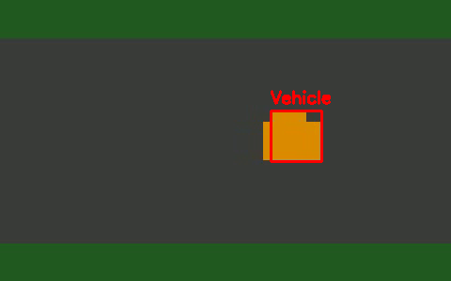

36. Draw Rectangular shape and extract objects.
Aim: To draw a rectangle to mark a region of interest (ROI) on an image and extract (crop) that region as a separate object using array slicing.
Program:
def exp36():
import cv2
img = cv2.imread("image.jpg")
x, y, w, h = 150, 60, 300, 230 # region of interest (ROI)

boxed = img.copy()
cv2.rectangle(boxed, (x, y), (x+w, y+h), (0, 255, 0), 3)
cv2.imwrite("boxed.jpg", boxed)

extracted = img[y:y+h, x:x+w] # extract/crop that region
cv2.imwrite("extracted_object.jpg", extracted)

Output:
